ENGR. EKENE AKUBUE BIO

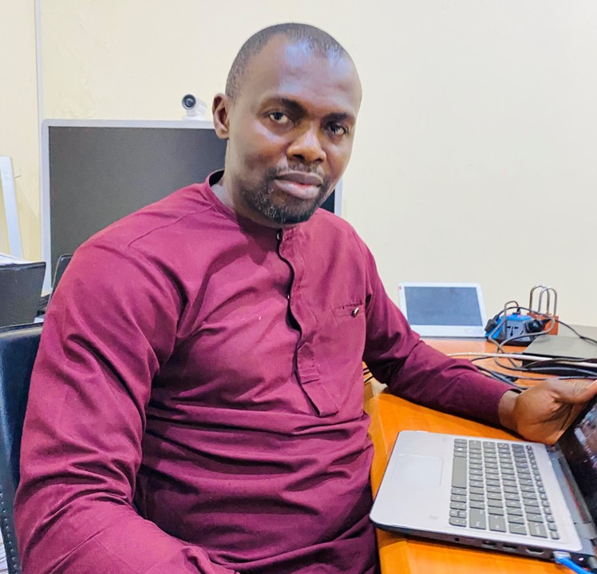Engr. Ekene Akubue is the Unit head Digitalization unit of ICT/Innovation Center University of Nigeria, Nsukka. He holds a Bachelor of Science Degree (B.Sc Hons) in Computer Education from University of Nigeria, Nsukka. He is a Senior Software Engineer, he holds MERN Certificate in software Development from Classvisa California, Frontend Developer Certificate from Genesys Tech Hub Enugu, Nigeria. He holds several certifications in Software Engineering from Coursera and Udemy Academy. A Member Teachers Registration Council Nigeria (TRCN). He has attended a number of professional training and workshops in software development, Networking, IT Support and Hardware maintenance.

Engineer Ekene currently works at Decode Investing New Jersey as a Frontend Engineer (Remote), he works at Expert Media Solutions as a Full Stack Software Engineer (Hybrid), He is the Chief Software Instructor at ICT/Innovation Center Skill-Up Program, University of Nigeria, Nsukka. He is Currently running a Master’s program in Vocational Technical Education on Software Engineering, University of Nigeria, Nsukka.

Mobile: +234 8032744865
Email: ekene.akubue@unn.edu.ng, ekeneakubue@gmail.com

